**Practical No: 2**

**Industrial Visit**

**Roll No. Name**

1. **186151 Shirsath kalyani Sahebrao**
2. **186156 Wagh Vedant Sunil**
3. **186157 Wakchoure Sarthak Kailas**
4. **186158 Wakhare Rohan Rajendra**
5. **186159 Yewalkar Tejal Prashant**

**Report on Visiting At Cyber Cafe**

**Name of Cyber Center:** Tuljai Xerox Center

**Location:** In front of Govt. Poly. Nashik, Samangaon Road, Nashik.

**Visiting Date: / /** 2019.

**Branch:** Computer Technology

## The Tuljai Cyber Cafe:

This is the **profitable small business** story of .Mr. Borade who has been in the cyber café visit (famously called tuljai) since 15 years. They are the one who printed all materials in polytechnic collage nashik.

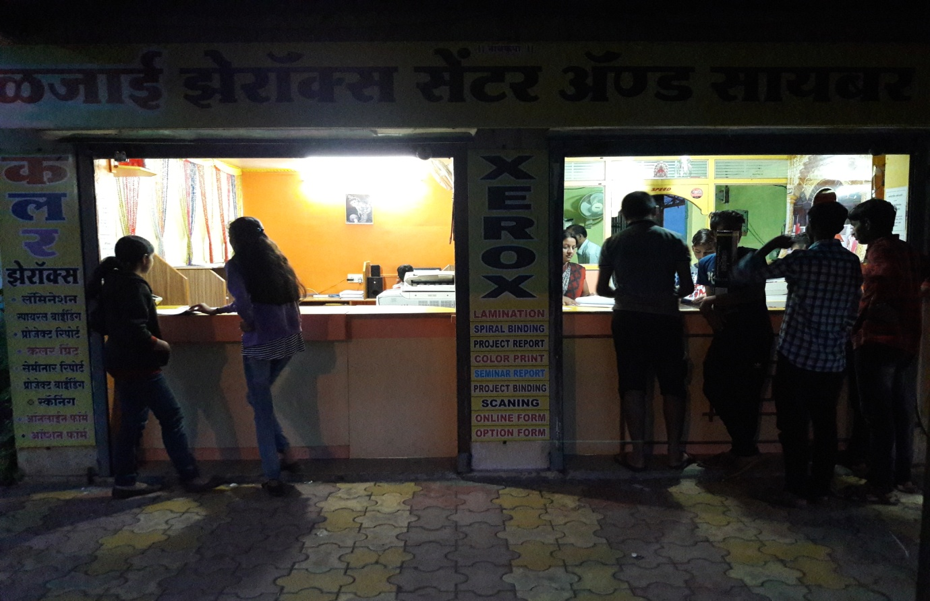

 For any of my xerox needs. Tuljai Xerox will be my go to person.  Even being surrounded by hundreds of other xerox centres, his shop attracts customers because of his competitive pricing, friendly customer interaction and on-time delivery which none others can match.

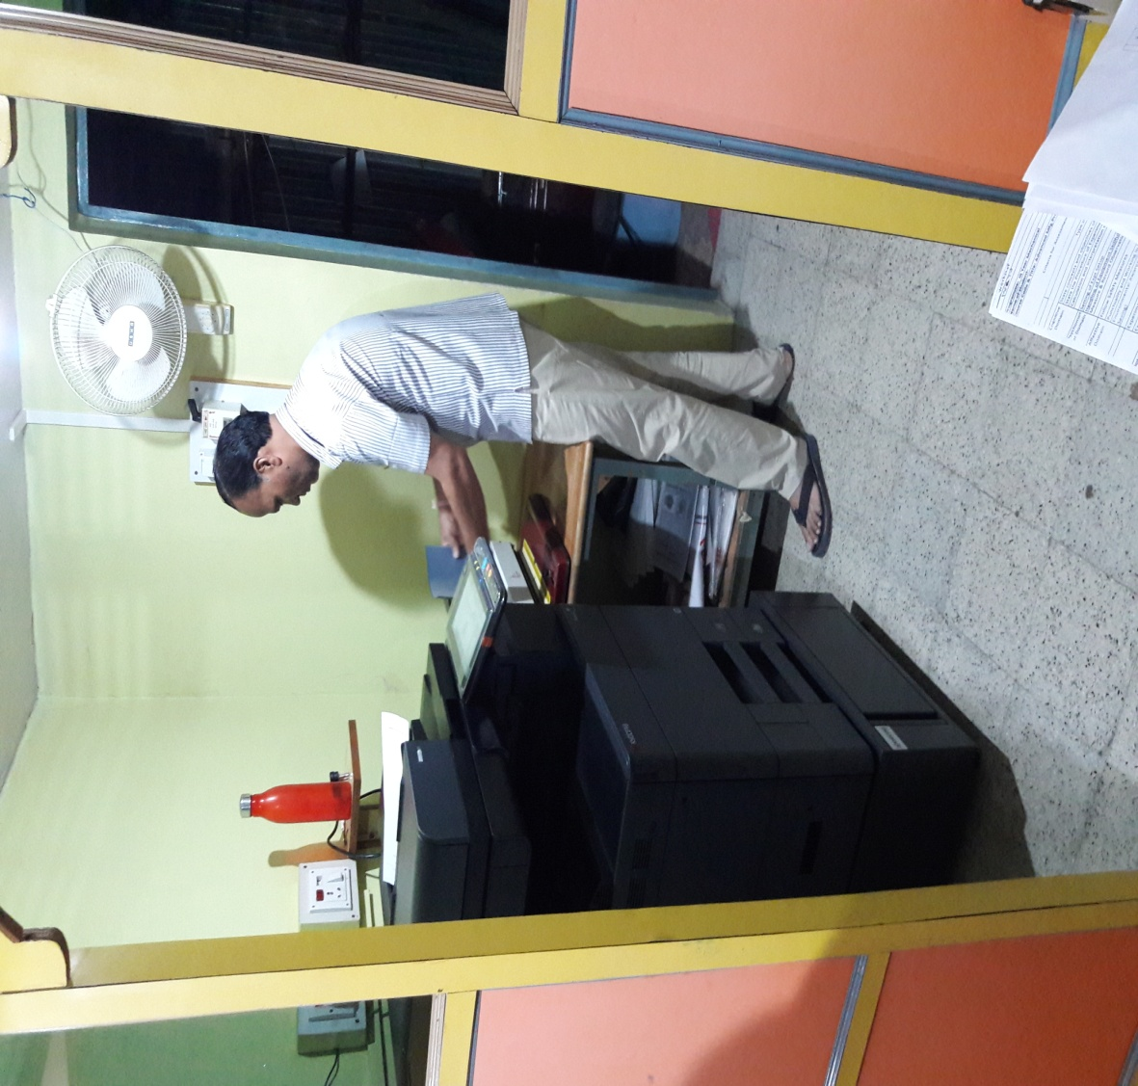

After working in a xerox centre for 15 years, he started off on his own with an initial investment of 50,000 rupees which he borrowed from his ex-employer Mr.hari. and milind

**Quick Look Into Their Business:**

* **Business Name**  : Tuljai Xerox Centre
* **Business Owners** :Mrs, V.Borade
* **Location** :In front of government polytechnic Nashik,Nashik
* **Industry Type** : Printing Business
* **Value Provided** :Photocopy, Printing, Binding, Lamination.
* **Waiting Time For**

**Availing Service** :Depends on your order.

* **Very Good At**   :Quality xerox copies on time
* **Timings**  ;8:00 am – 10:00 pm
* **Customer Interaction**: Very Good ( Ratings: 4.5 / 5 ) .
* **Daily Challenges**:
* Taking photo copies of less than 5 sheets becomes a problem  as the machine draws huge power for small number of prints. Customers are annoyed when such orders are rejected.
* Machine maintenance is a big problem, especially when various parts of the machines remains unavailable.
* **Customers**: Training Institutes, school/college teachers, students
* **Machines:** Xerox Machines of 3.5 lacs, Modems, Printer, Scanner, Lamination machine
* **Number of Employees**: 3 employees work.

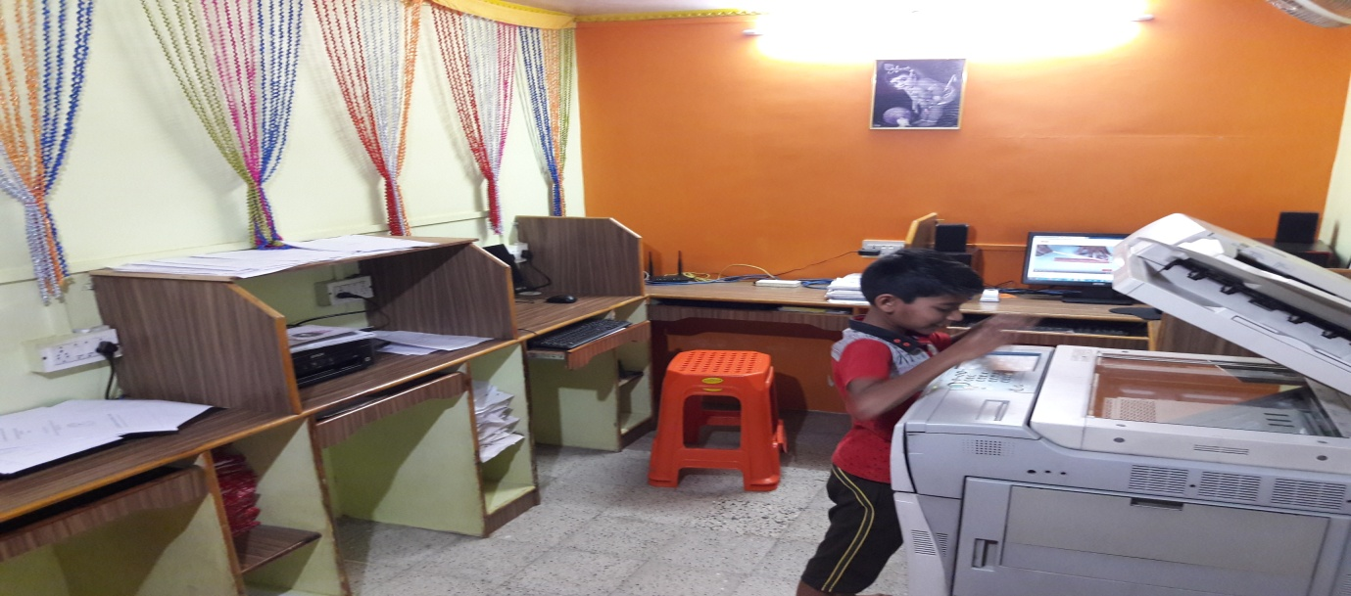

**Benefits from Tuljai:**

1. Customer retention can be achieved through healthy customer relationship and high customer satisfaction.
2. The size of the business premises should not limit the size of our thinking. Though,  office looks would play a role in attracting customers, it can be overcome by providing great customer experience.

**Conclusion:**

After visiting this cyber cafe we observe different and expensive machines which are more than 3 lacs in cost. They also provide very good service to their customers. All the work related to Xerox ,printing, scanning are available in Tuljai cyber café. Their income also very good near about Rs.2000-3000 /day. During submission it grows on Rs.4000-6000/day.